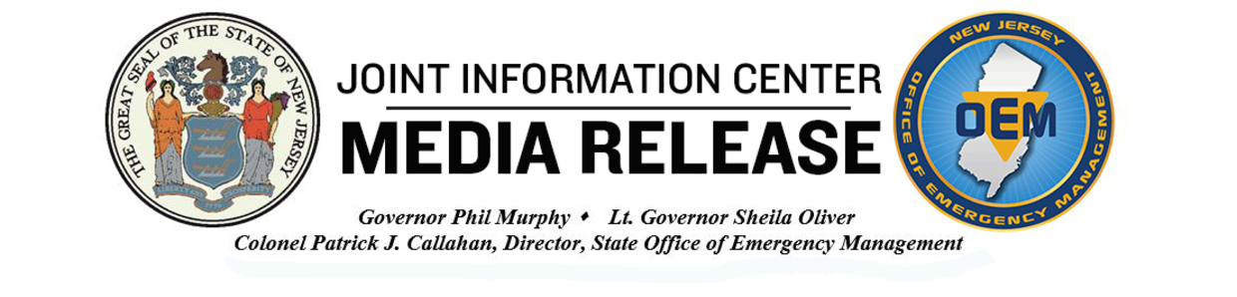

COVID-19 Press Information

FOR IMMEDIATE RELEASE
June 9, 2020

CONTACT: Jerrel Harvey
Press Office: Governor's Office
Email: Jerrel.Harvey@nj.gov

Governor Murphy Signs Executive Orders Lifting Limits on Indoor and Outdoor Gatherings, Opening Pools Effective June 22, and Opening Additional Outdoor Recreational Businesses

Governor Phil Murphy today signed two executive orders 1) raising limits on outdoor and indoor gatherings and 2) opening pools effective June 22 and additional outdoor recreational businesses effective immediately.

“With more of our businesses reopening, we are no longer requiring New Jerseyans to stay at home, but we are asking you to continue to be responsible and safe,” said Governor Murphy. “These actions will put us even more firmly on our Road Back and complement the steps we’ve already taken to begin our restart and recovery.”

Under Executive Order No. 152, effective immediately, indoor gatherings are limited to 25 percent of the capacity of the room, but regardless of the room's capacity, such limit shall never be less than 10 or more than 50 people. All attendees at the gathering must wear face coverings, unless for a medical reason or if the individual is under 2 years old, individuals must remain six feet apart at all times, and physical items may not be shared by multiple attendees of the same gathering unless sanitized before and after uses.

Outdoor gatherings are limited to 100 people, and attendees are required to be six feet apart. Individuals should wear face coverings at all times where social distancing measures are difficult to maintain, and individuals who are in vehicles shall not count towards the gathering limit.

Nothing in the Order shall prevent a person at a gathering from momentarily removing their mask to place or receive an item in their mouth, if done for religious purposes, or for health and safety.

Additionally, available parking at State Parks and Forests, and at county and municipal parks, may reopen to their full maximum capacity.

Under Executive Order No. 153, outdoor swimming pools can open effective at 6:00 a.m. on Monday, June 22, provided that it complies with standards and policies that will be issued by the Department of Health. Pool facilities may open for the purpose of lifeguard training and lifeguard swimming lessons prior to June 22.

Additionally, outdoor recreational and entertainment businesses are permitted to reopen immediately, with the exception of amusement parks, water parks, and arcades. These recreational and entertainment businesses are required to abide by a number of social distancing protocols that are specified in the Order. Any type of event at an outdoor recreational or entertainment business that involves individuals there at a specific time for a common reason, such as a movie or concert, are subject to the restrictions on outdoor gatherings.

Public and private social clubs are permitted to reopen their outdoor spaces, provided they comply with all applicable terms of the Order. And nothing in the Order prevents a business from operating an amusement game outdoors, such as a game on a boardwalk, so long as the game does not take place in an amusement park and an employee is present and adheres to all of the requirements in Paragraph 1 of this Order, including sanitizing all equipment before and after each use.

Paragraph 2 of Executive Order No. 107, which requires New Jersey residents to remain home with limited exceptions, is formally rescinded. The other provisions of that Order, including the requirement that businesses or non-profits accommodate their workforce for telework or work-from-home arrangements, wherever practicable, are still in effect.

For a copy of Executive Order No. 152, please click here.

For a copy of Executive Order No. 153, please click here.

