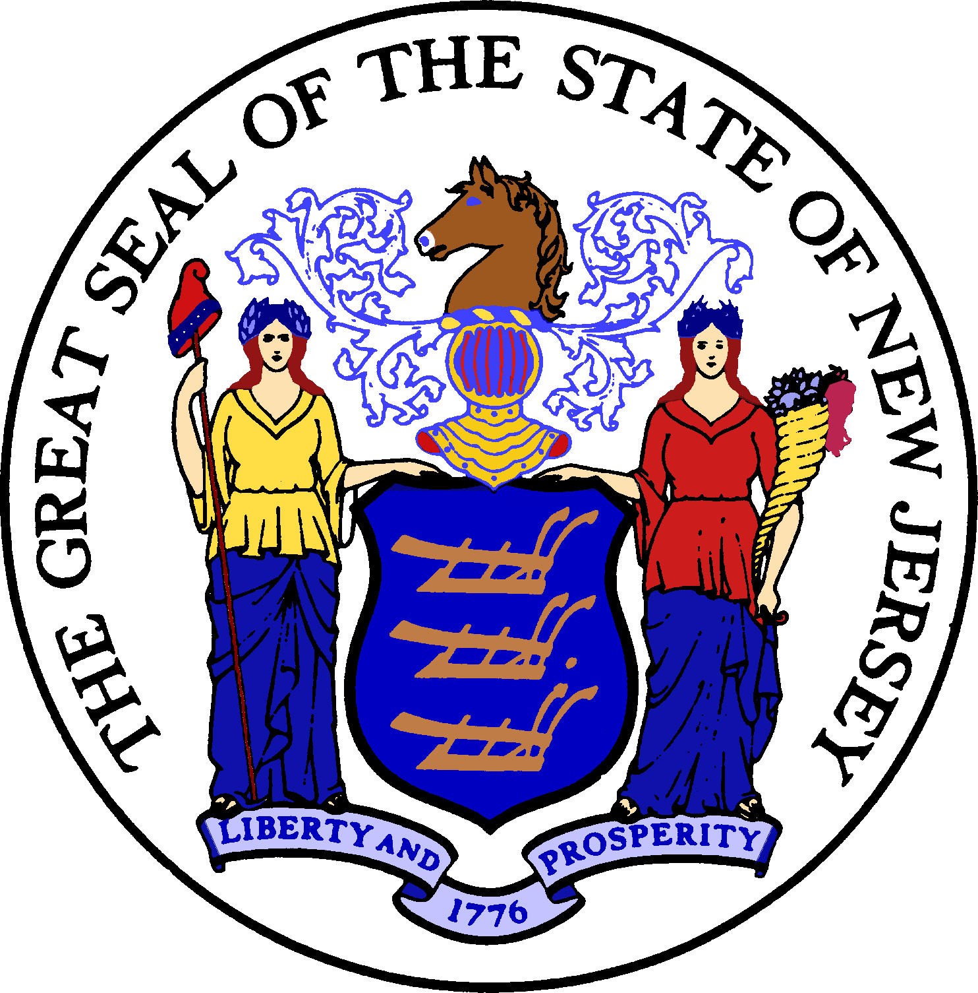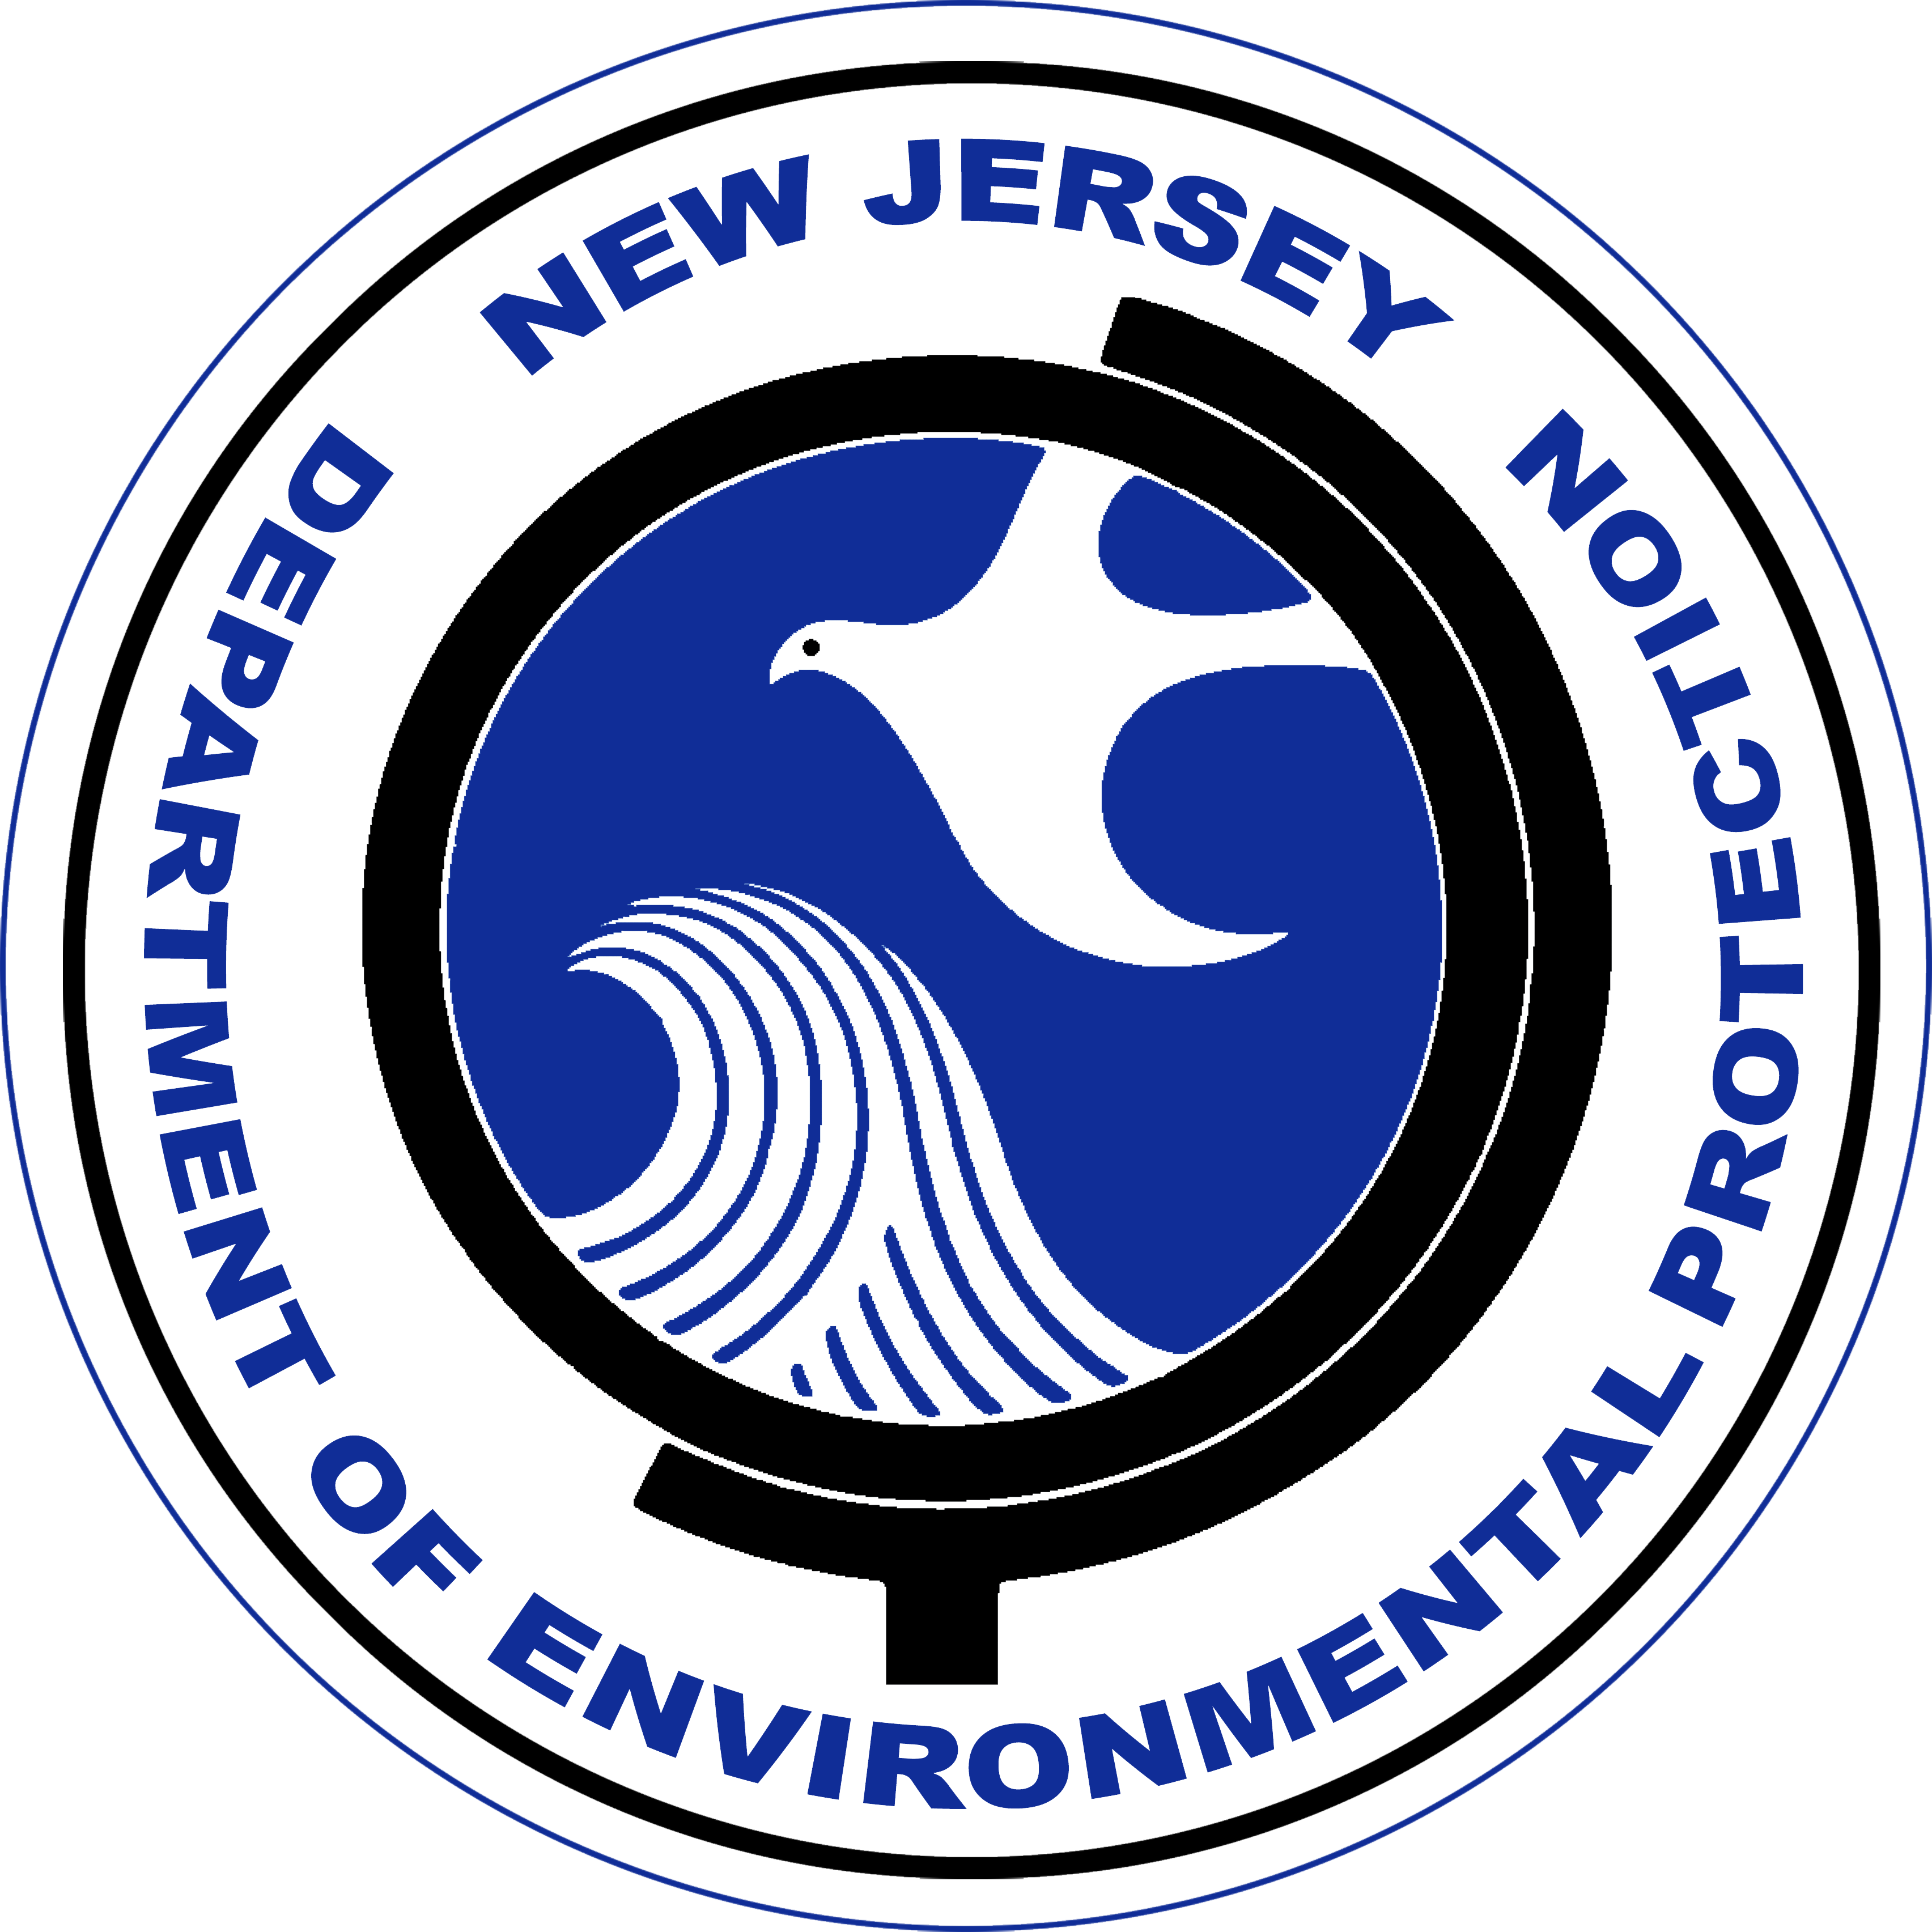

Construction of upgrades and improvements to the Stafford Township, Beach Haven West Sanitary Sewer Replacement Project Phase 6 in the amount of $11,263,000 was financed by the New Jersey Water Bank (NJWB). The NJWB is a State Revolving Fund program jointly administered by the New Jersey Department of Environmental Protection (DEP) and the New Jersey Infrastructure Bank (Infrastructure Bank) and uses a combination of funds provided by the United States Environmental Protection Agency, the DEP, and the Infrastructure Bank to provide very low interest loans to borrowers for environmental infrastructure projects.

This project will provide water quality benefits through the replacement of the existing asbestos concrete sewer main, sewer services, and aging manholes for residents and businesses in Beach Haven West, Stafford Township.

State Revolving Fund programs around the nation provide states and communities the resources necessary to maintain and improve the infrastructure protecting our valuable water resources nationwide.

